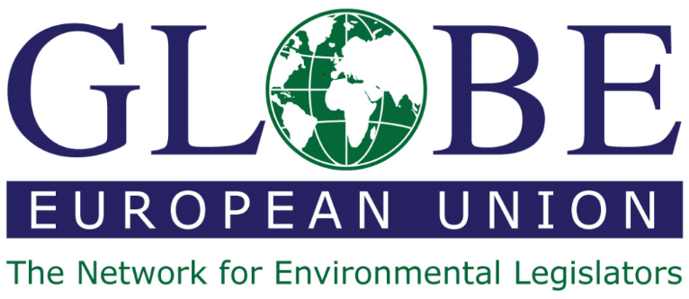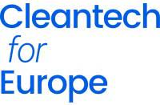

Building the Future: Can clean technologies pave the way for zero-carbon construction?
September 6 from 16h00 to 18h00
Program:
- 16h00 Welcome – Sirpa Pietikäinen MEP, President GLOBE EU
- 16h05 Opening remarks – Jules Besnainou, Director, Cleantech Group
- 16h10 Keynote Address – Fulvia Raffelli, Head of Unit, DG GROW H.1 (Construction)
- 16h20 Expert introductions (5’ each):
- Jean-Christophe Trassard, Director, Marketing of Sustainable Innovation – Ecocem (developing zero-carbon cement)
- Myriam Tryjefaczka, Sustainability and Public Affairs Director EMEA – Tarkett (applying circularity to construction materials)
- Johanna Pirinen, SVP Head of Sustainability, Wood Products Division – Stora Enso (advanced wood construction)
- Hedwig Heinsman, Co-founder – Aectual (Circular 3D-printed architectural finishes from waste materials)
- Nicolas Cruaud, CEO – Neolithe (converting household waste into granulates for construction)
- 17h20 Discussion:
- What is the potential impact of clean technologies on the construction sector by 2030?
- What are key barriers to scale for these technologies?
- What regulatory framework would help accelerate their adoption in the EU?
- 17h50 Conclusion – Martin Hojsík MEP, Vice-President GLOBE EU

