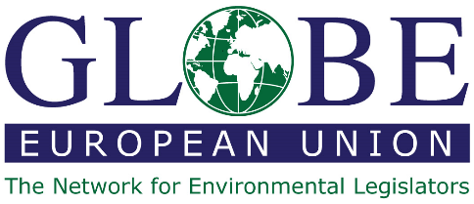

GLOBE EU event of March 28, 2023
After the UN 2023 Water Conference: Fighting Water Pollution

Host:
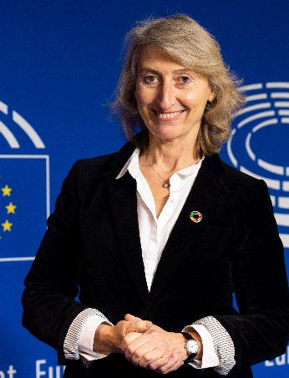
Catherine Chabaud is a French journalist and sailor, born on 29th November 1962 in Bron (Rhône). She is best known for her remarkable achievement as the first woman to complete a single-handed, non-stop, round-the-world sailing race in the third edition of the Vendée Globe (1996-1997). Her experience of witnessing the levels of pollution in the ocean during her races motivated her to become an advocate for protecting the environment and promoting sustainable development.
She went on to co-found the Ocean and Climate platform and launch an initiative to recognize the ocean as a “common good of humanity". She was also an advisor to the Economic, Social and Environmental Council, and a delegate for the sea and coastline at the French Ministry of the Environment, Energy, and the Sea in 2016 and 2017.
On 26 May 2019, she was elected a Member of the European Parliament on the Renaissance list, affiliated with Le Mouvement Démocrate. In the European Parliament, she is active on the Committees on Development, Environment and Fisheries, and is working on maritime topics.
On 9 November 2022, Catherine embarked on the Route du Rhum, a legendary solo yacht race from Brittany to Guadeloupe, where she arrived in second place. This participation is directly linked to her mandate as a Member of the European Parliament, as it aims to raise awareness of maritime issues and the need to protect the ocean.

Speakers:
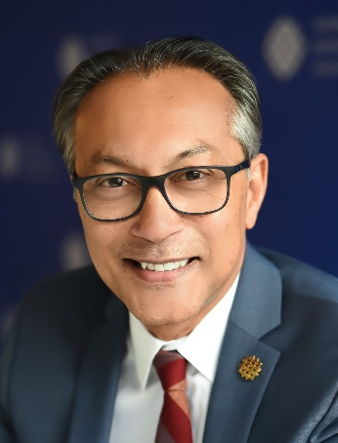
Ani Dasgupta is President and CEO of World Resources Institute, where he works to advance the institute’s global vision to improve the lives of all people and ensure that nature can thrive. Ani took the helm at WRI after seven years as Global Director of WRI’s Ross Center for Sustainable Cities, which is dedicated to shaping a future where cities work better for all people. He developed his expertise in positions ranging from nonprofits in India to the World Bank. A widely recognized leader in the areas of sustainable cities, poverty alleviation, and building cultures of inclusion, Ani has a history of building strong cross-sector, multi-national coalitions with governments, corporations, and civil society.

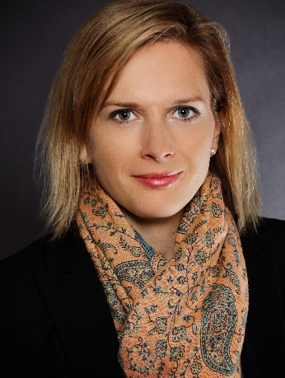
Veronika Hunt Safrankova is Head of the Brussels Office of the United Nations Environment Program (UNEP). Since April 2019 she has worked closely with EU institutions and Brussels-based stakeholders on key policy areas to strengthen partnerships, cooperation and joint efforts to address global environmental challenges.
She joined UNEP after a four-year assignment at Charles University in Prague, during which she worked on internationalization and partnerships as Director of International Relations Office. Later, as a policy advisor based in Warsaw, Veronika was involved in preparations for the establishment of the 4EU+ European University Alliance.
Prior to that, she worked for public administration in the Czech Republic. During the more than twelve years at the Czech Ministry of Environment, Veronika held a number of different management positions, including First Deputy Minister, covering various areas – international cooperation, sustainable development, EU environmental legislation, EU funds, national environmental policy, strategies and instruments, and representation of the Czech Republic in relevant European and international bodies.

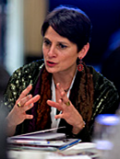
Veronica Manfredi is the Director for Zero Pollution (former Directorate Quality of Life) in DG Environment since February 2018.
Her Directorate plays a pivotal role in leading Europe towards Zero-Pollution and securing an effective management of Water – it thus significantly contributes to tackle the Climate, Biodiversity and Circular Economy challenges. It is indeed responsible for EU policies on Clean and Well-Managed Water (including the protection all EU Freshwater and Marine environments, water reuse, prevention from Floods, compliance with high health standards for Drinking Water), Clean Air, Environmental Noise, control on Industrial Emissions and prevention of Industrial Accidents. It also steers on the sound implementation of the Green City Accord which, in synergy with the Smart Cities Mission, the Covenant of Mayors and other urban initiatives, aims at tangibly delivering on the European Green Deal goals at local level.
Internationally, her team leads the EU negotiations within the UN Minamata Convention on Mercury and the UN Convention on Long-Range Transboundary Air Pollution. It also provides steady support to the work of the four Regional Sea Conventions (notably the HELCOM – Baltic Sea, OSPAR – North Atlantic Sea, Barcelona – Mediterranean Sea, and the Bucharest Conventions – Black Sea) and the International Commissions for the Protection of the Rhine and Danube rivers.
A lawyer by background, Veronica deepened her knowledge of International and EU law in Rome, Turin, Kiel, Bruges, and Brussels.
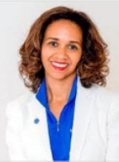
Tiffany Atwell is the Senior Vice President of Government Relations for Ecolab, a role she has held since November 2020. Prior to this, Tiffany was the Vice President of Global Government and Industry Affairs for Corteva Agriscience, where she led a global team focused on shaping government policies and regulations that impacted Corteva’s freedom to operate in the US, Asia, Latin America, Europe, Middle East, and Africa.
Before joining Corteva Agriscience, Tiffany spent over a decade in the US government in various international policy roles. She began her career as a U.S. State Department Presidential Management Fellow and received a U.S. State Department Meritorious Honor Award for her work. She later served as the International Trade Policy Advisor for Senator Grassley, Chair of the Senate Finance Committee.
In 2006, Tiffany began her business-focused career at Abbott as a Director of Global Government Affairs. She was later promoted to Senior Director for Strategic Programs, where she developed external engagement strategies for India, Russia, and China to promote market access for key products. For her excellence in her roles, Tiffany was the recipient of the Abbott President Award in 2010, 2011 and 2012, as well as the Commercial Excellence Award in 2011.
Outside of work, Tiffany lives with her family in Washington, DC. In her spare time, she enjoys volunteering and mentoring young professionals. Growing up economically disadvantaged in North Carolina with her mother as the primary financial provider, Tiffany is passionate about giving back to society and helping people that face similar barriers to financial independence.

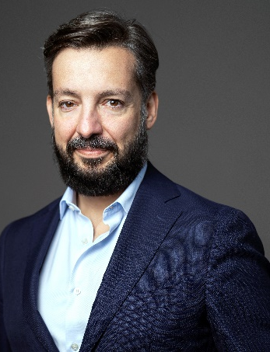
João Ribeiro-Bidaoui is General Counsel & Director of Global Public Affairs at the non-profit The Ocean Cleanup, steering its engagement with Governments, International Organisations, and like-minded institutions, and managing the negotiation of the coming UN Global Plastics Treaty. He has held leadership positions in intergovernmental organisations for over 10 years (OECD, UNCITRAL and HCCH) after heading the international relations of the Ministry of Justice of Portugal, representing his country in several treaty negotiations. João is a recognised expert on commercial law reforms, having contributed, with UNCITRAL, the World Bank, and the Asian Development Bank, to the modernisation and harmonisation of laws in China (including Macau and Hong Kong SARs), Fiji, Laos, Mozambique, North Korea, Papua New Guinea, Thailand, Timor-Leste and Vietnam. He has a law and master’s degrees from the University of Coimbra (Portugal), a master’s in International Relations from the University of Cambridge (UK), and a PhD in Sociology of Corruption from NOVA University of Lisbon.

