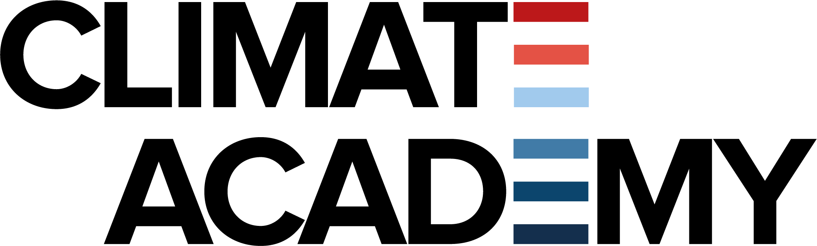

EU Overshoot Day event , April 9 2024

Summary Round One:
Participants: Sirpa Pietikäinen MEP, Heidi Hautala MEP, Sarnath Gesquiere, Beatrise Prince, Petra Lindholm
Sarnath Ghesquiere
Sarnath's question: Does the EU have guidelines or targets to reduce material consumption to sustainable levels by 2050?
Heidi's response: The European Parliament calls for binding targets on resource efficiency alongside carbon neutrality targets. The EU needs to set targets to encourage institutions to find means to reduce consumption. There are efforts like product durability legislation, but more work is needed to address the increasing waste, especially from electronic products.
Sarnath's follow-up: How can European citizens be informed about the progress towards these targets?
Heidi's additional comments: Public campaigns and systemic solutions are needed. The European Parliament has emphasized resource efficiency. The next term will focus on making resource efficiency a reality.
Beatrise Prince
Beatrise's question: What legislation would you propose to mitigate the fashion industry's negative impact on the carbon budget?
Sirpa's response: Company reporting should include environmental impact, similar to financial accounting. The idea of taxing resource consumption and emissions instead of profits could incentivize cleaner operations. The "do no significant harm" principle should be clearer, with actions like banning fossil fuels by 2030-35.
Heidi's additional comments: Supply chain legislation requires companies to ensure no human rights violations or environmental destruction in their supply chains. The corporate sustainability reporting directive is also important.
Beatrise's follow-up: How can we avoid prematurely exhausting our carbon budget?
Heidi's suggestion: Public campaigns like billboards showing the countdown to when the EU exhausts its carbon budget could raise awareness.
Sirpa's additional comments: Media should report on climate change regularly, showing progress and solutions. Subsidizing fossil fuels should be redirected to sustainable finance.
Petra Lindholm
Petra's question: What regulations are needed to reduce the textile industry's impact on waste management?
Heidi's response: France is leading with bans on burning returned clothes and discussing an EU-wide ban on exporting old textiles. Textiles should have a product passport for recycling.
Petra's follow-up: How can we prevent the increase in resource extraction for green energy?
Heidi's concern: The push for electrification and digitalization requires critical raw materials, which could lead to environmental costs. Circular economy principles are essential to address this.
Summary Round Two:
Participants: Sirpa Pietikäinen MEP, Margrete Auken MEP, Brielle Silveira, Neil Blenkinsop, Valentina Huitfeldt
Brielle Silveira
Brielle's first question: Is it fair to compare India's emissions to those of ultra-high developed nations given their historical emissions?
Sirpa's response: Climate justice should be considered, with the idea of a global climate budget where over consumers buy allowances from under consumers like India.
Margrete's additional comments: All countries, including India, must act to ensure a future for the younger generations, despite historical injustices.
Brielle's second question: Why should India and China reduce emissions when developed nations have higher per capita resource use?
Sirpa's response: All countries must act, as they are responsible for a significant portion of emissions and will suffer the consequences. Sustainable development is essential for quality of life.
Margrete's additional comments: India and China should not repeat the mistakes of developed countries and should lead by example in sustainable practices.
Neil Blenkinsop
Neil's question: How can young people deal with climate anxiety and anger over inaction?
Margrete's advice: Maintain anger, include older generations in the fight, and organize. Being active helps combat climate depression.
Sirpa's additional comments: Young people should communicate their dreams for the future and demand action, as the next 10-15 years are critical.
Neil's follow-up: How can we shift the narrative towards systemic change rather than individual actions?
Margrete's response: Individual actions are important to inspire systemic change. Organizing and voting are crucial, and young people must be knowledgeable and vocal.
Sirpa's additional comments: Telling positive stories of what is possible can create demand for action, but it must be clear that these changes are not happening yet and require concerted effort.
Valentina Huitfeldt
Valentina's question: How can we tackle opposition to policies like the Green Deal from farmers and others?
Margrete's response: The real opposition is from the agri-chemical complex, not farmers. Sustainable farming is possible and necessary for environmental health.
Sirpa's additional comments: A network between consumers, retailers, and sustainable farmers could help change public procurement and support sustainable farming.
Valentina's follow-up: Should we focus on positive stories or the urgency of drastic measures?
Sirpa's response: Positive stories should illustrate what can and should be done, not what is already happening, to demand action.
Margrete's additional comments: Positive stories are useful if they show viable alternatives and are not used to downplay the urgency of the situation.

